
a sever-based web-page
witch Star net

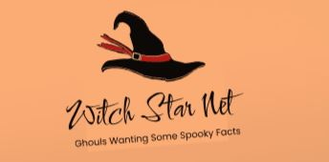
September 30, 2023
emma Davidson
Edinburgh Napier SET09103

- Introduction
In this academia writing I will be elaborating the importance of web-sever page, which most likely will use the http protocol. For my assignment I have been tasked to create a server-side web page, this could be anything as long as the webpage is server-sided. Therefore, I decided to create a Halloween based quiz app. Deciding to create the quiz app Halloween based was as I have a strong and great knowledge of Halloween as it is my favourite holiday. After last assignment about the proposal of the sever-side web page, Witch star net. This project will focus on the positive and negative aspects when creating the witch star net.

- Function explanation of what has been implemented in the Witch star net

For this project we are asked to create a server-side web-application, although web-apps and websites are very similar looking they are different. The core differences between them are their functionality, for a website it is normal for it to give information about anything that the user is looking up, or the website accepts simple inputs from the user. Whilst web-apps focus on the users input and go above and beyond to be more interactive with the user, an example of this could be asking for a name for the user that the web-app will then use throughout the users’ time.
The core aspect of this project is to create a programme that is a website, using python-flask and HTML to attract users to play a themed quiz based on some amazing Halloween movies. Some examples, nightmare before Christmas, Beetlejuice, Halloween town, and corpse bride. With the functionality of the web-app I would like to add a counter for how many right answers the quiz-user has received this can also act as an application programming interface (API), I was able to create a counter of all the correct answers given by the user. I created this counter with java script. We create the counter by first setting the function to zero therefore, we want the initial variable’s value to not affect the result we are looking for in this example we are looking to see the score of the quiz. I created this counter so we would have a certainty on whose score is better between multiple users, this can also let us gage where people are struggling with the questions.
Another useful function I would like to implement into my server-side web-app, would be for a colour change when the answer is right and or wrong, doing this will make it easier for the user to identify if they have the appropriate answer or if they are completely wrong. To explain what this is useful for I will be using the words from “Studies suggest that people make a subconscious judgment about a product within 90 seconds of initial viewing. Up to 90% of that assessment is based on colour alone.” Therefore, colour in web-applications is vital, more importantly choosing the right colour to depict the scene that this being shown through the work of code. For this project I would believe that a more drastic colour scheme would be too much for the user as well as not very inclusive for those who have trouble reading on different colours, therefore I decided the best solution was to create a white background colour with colour added into the header of the pages and more intricate design methods so the whole page is not cluttered with colour.
Due to the fact that web-quiz apps are so popular, in this day in age, and one that most people know today is a quiz called wordle, which is a guessing game on what the word of the day is, this can be seen as a quiz as it tests your knowledge to see if you are able to change your beginning word to the end word whilst guessing the correct word. In this quiz it uses the technique of colour to show which letters of the word of the day are correct and which are not. For my quiz app I would like to use this simple yet important technique to differentiate the correct answer and a wrong answer. Although wordle uses the colour to show which letter is in the right order and which are not I would be using this technique only to notify the user if they got the wrong or right answer as they press next, then it will show the correct answer at the end on the answers page.

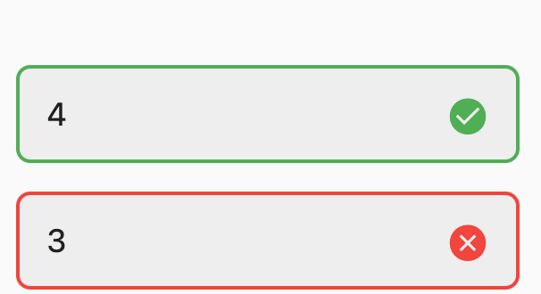
figure 1: colour different of answer
As well as the possibility of creating a system where it could recommend different quizzes with a similar aspect. For this I was able to create an internal webpage that users can click on to see full images of the quizzes I have available but on other platforms, I created these so users can test their knowledge on other quizzes with the
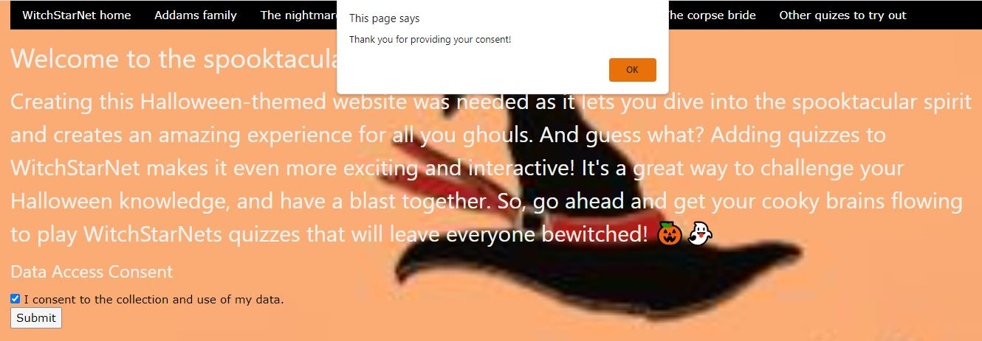
A possible function I would like to implement, is cookies. Cookies are designed for two different purposes, one is used as authentication, this is mainly used in websites that need verification that a user is themselves. An example of this type of http cookie could be the Student Awards Agency Scotland (SAAS) website, as the website has confidential information it needs to check the user is who is trying to access the website, the most known way to do this is through login details. For this coursework I was able to implement a simple cookie that once the user has clicked to accept the browser, they are on the will then send a “thank you” for accepting the cookies.

- The Implementation Plan

The first thing that needs to be done is connecting the different languages together this is the http protocol, using this will allow me to have a more secure communication between me and the user. With using a small amount of html to create the basic web pages, figure shown below. From there I will then use java script to create a more interactive web-application it is seen that more interactive web-application perform much better than static web-applications “Interactive elements can provide a sense of interactivity, entertainment, and value, making visitors want to spend more time on your site.”, this incite gives us more need for websites to be interactive, i.e. have more moving objects as that is what to (K. Manning04/05/2023) keeps the user on the web-application. Henceforth, I will focus on the functionality. I would like to then focus on creating tracking cookies for the website, this will be used to make sure that the answers page stays private till the end of the quiz. From there I will implement in the advertisement page with a slide show of different quizzes available on different web-applications. This will allow the user to view more quizzes that they can enjoy. Then with the help of the use of python flask I will be able to publish the actual web-application using the virtual machine. If time allows me to then I will create more quizzes for the user to enjoy.
I believe I excelled in creating a working professional navigation bar where it allows the user to access all points of interest of the web page with ease. What I mean by this is, creating a navigation bar using W3 CSS, which is a type of CSS which supports a modern CSS framework with built-in responsiveness. What this means is that this type of CSS needs less code and is responsive to what the coder has written. It is a library I implemented into all the web pages; we have available on witch star net. I do believe if the time allowed me to, I would have implemented breadcrumbs so that users can get back to the page they were on before they clicked on another page.

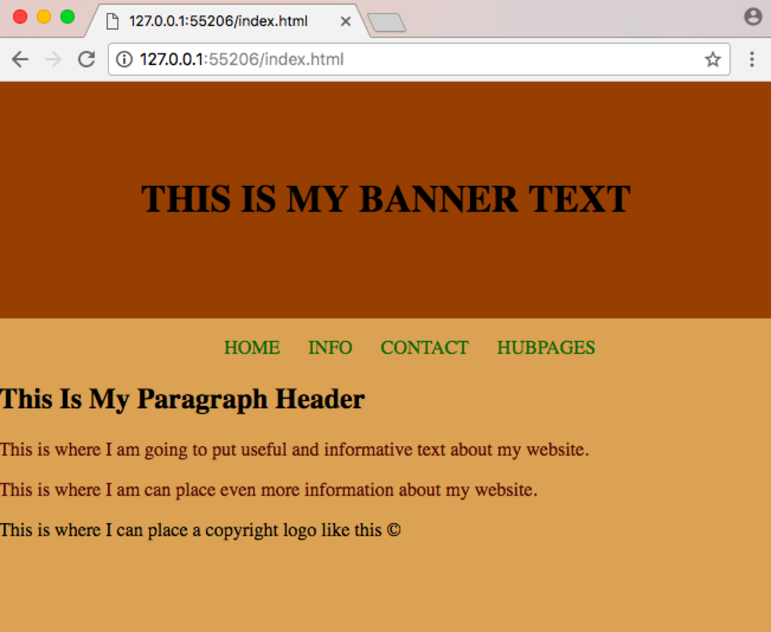
figure 2: basic html website

A final function I would like to implement into witch star net, is a slideshow function that will utilis my skills in JavaScript, CSS, and html. I will create this by almost making a grid system with multiple images stacked on top of each other that can be scrolled through, we will be using the help of the slide function so the images slide through more effortlessly. This particular function using document, to then get the image to then a line them to create the slideshow. For this part it was definitely difficult to implement, I ended up creating a slideshow of different images from the quizzes that created and then linking those images to other web pages with similar quizzes available. This allows the users to test their knowledge more and get into the rhythm of the quizzes we have on Witch Star net. In the future I would like to maybe implement in a pop-up option of different quizzes than the themed ones we have on witch star net. To create the slideshow, we use an almost carousel function where basically having multiple images stacked on top of each other and if the user does not click on the shown image, it will then the next image appears. It basically works by hiding the images that are behind the first image. Then if the user does click on the image, it does take the user out of the website to an external webpage unless the user clicks the link on the home page as I used an iframe tag to show the links on the home screen therefore, the image is smaller overall. Meaning if the user is to click the link on the home page the user does stay on the website, the only think is it is quite hard to click on the answers of the other quizzes we have as the advertisement page.

Figure3: slideshow representation 1

- Witch star nets webpages
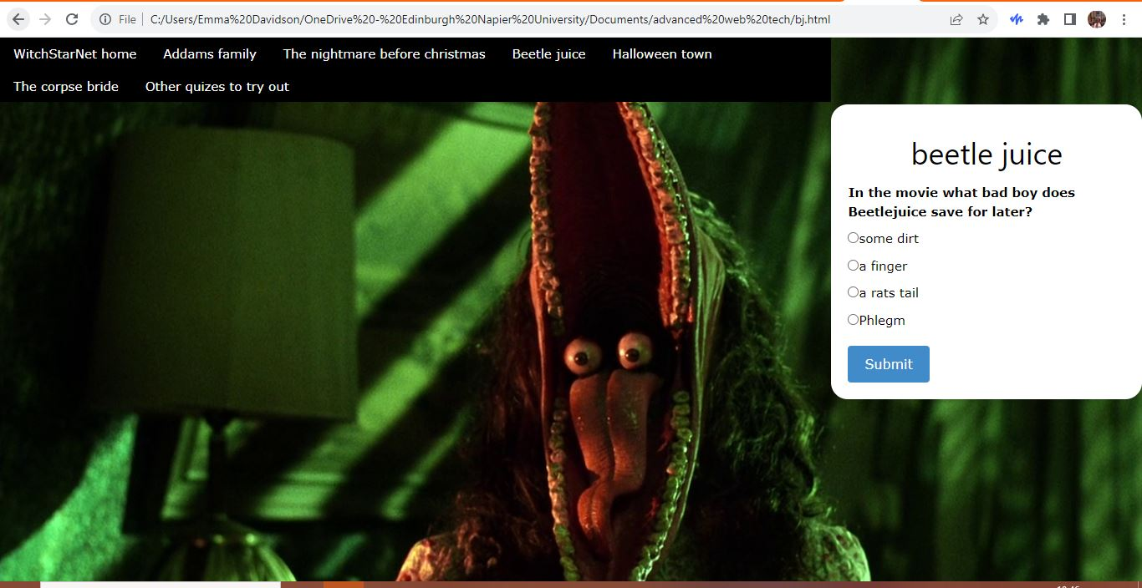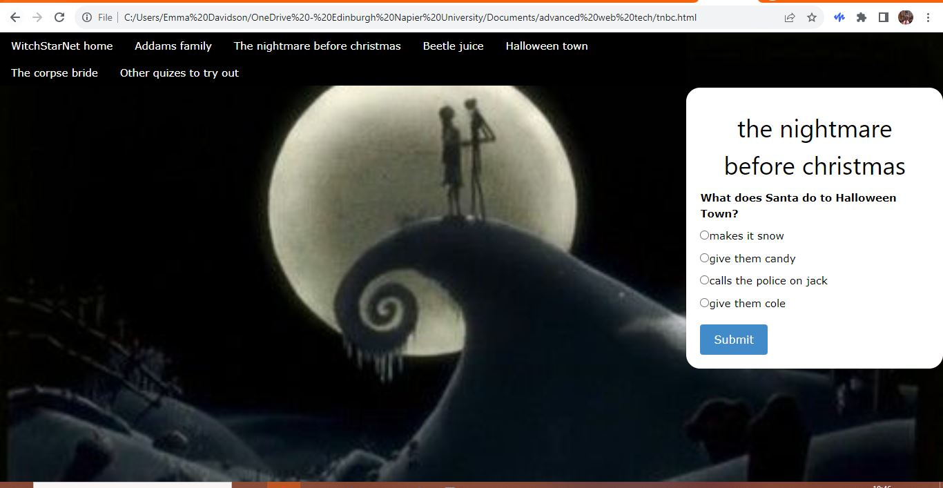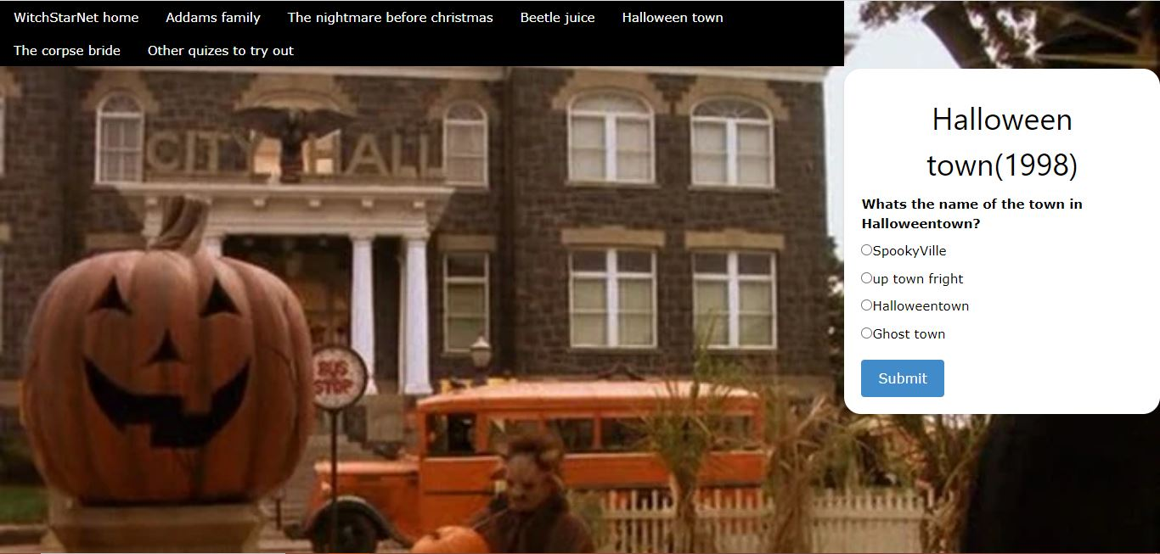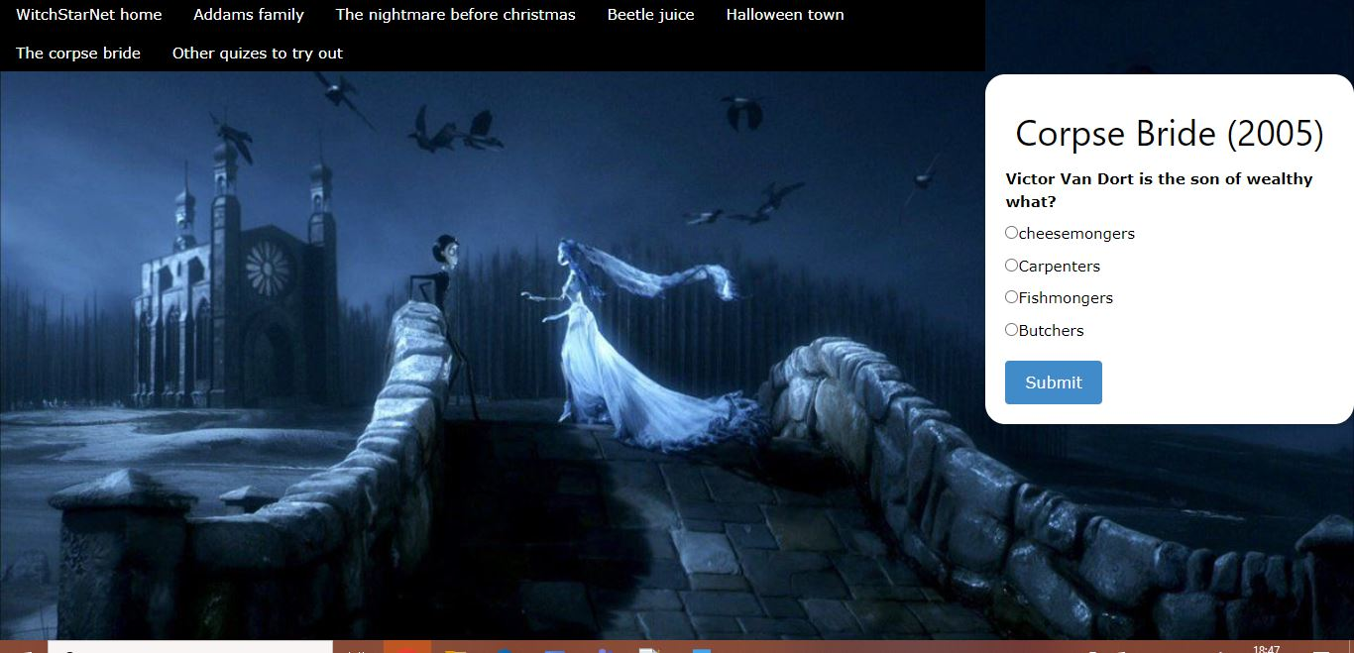
figure 4: witch star net wireframe

For the web-application, there shall be three main pages, the home screen that the user will first enter on. Then the main page for the web-application will have the advertisement page linked to it with, the adverts will be shown as a slide show of all different quizzes the user can then exit the current web-application to go on to the advertisement’s web-application. Though if the user would like to play the quiz that is available on the web-application created it will then to the user to a page where there is the quizzes answers and the actual quizzes, preferably I would like to implement a type of barricade that stops users who have not played the quiz to not be able to look at the answers. For the barrier I will be implementing the https tracking cookies that I have explained above, I believe for this specific project this is the most important part I would like to implement. I originally thought about creating a database that would take a small piece of data from each of the users and if it comes back that the user had in fact completed the quiz then it would only then let the user onto the answers page, and if the user had not completed the quiz the answer page would stay private, this would almost act like a search, searching if the user has completed the quiz or not. But after deliberating and talking it through with Simon Wells, my lecture. I realised that my idea was going to be extensive work for something that has already been created the https cookies.
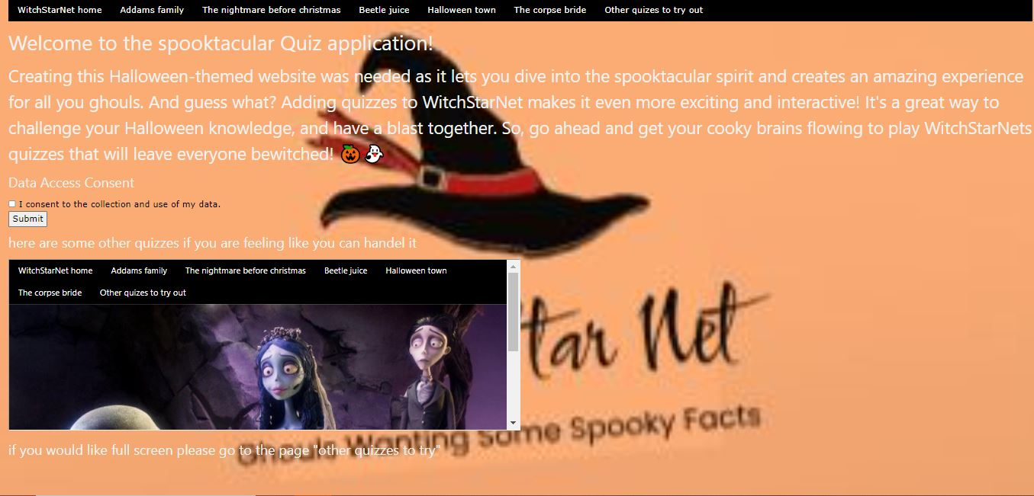
Figure 5: page layout
As seen above, this will be the layout of all the pages. I have implemented in the navigation bar which should help users to find there place on the website. This will allow the user to have a representation of what pages they have looked and have an easier time on traveling back to the page they would like to return back to. There will be links to the quizzes with blurbs of what the quizzes intel.

- Consideration of security & privacy
Can talk about the cookies within here as it is a part of security to the web-application.
When talking about security and privacy within the web-application, It is important to keep in mind that it has to consensual between the user and the web-application its self. Not asking a user for the web-application to hold data about the user, even if it is insignificant as whether the user has completed the quiz or not, is illegal. Therefore, most current day application asks the user whether they would like to use cookies or not. Cookies are a small file that is used to keep if the user has used or done something, an example of this could be an online shopping web-application that remembers what has been put into the shopping cart, this can also be used to them promote other items the user may be interested in. For witch star net, we would be using the cookies to make sure that the answers page would stay private until the cookies has been notified that the quiz has been completed, as during the quiz you will only know that you are wrong, the same way that the Moodle quizzes works but the user gets told that an answer is wrong. Due to the fact that for this web-application we will be using first-party cookies which are a lot safer. “Unlocking the power of all your first-party data is the key to maintaining a competitive edge and delivering a consistent experience to all your customers, across all channels.” said (K. de Leon 3/30/23.) As it explains using first-party https cookies allow the web-application to keep good communication between the user and the web browser.

- Consideration of underlying protocols

When understanding the underlying protocol needed for the website, we need to understand the protocol HTTPs. We use https on websites as it secures the communication between user and browser. We do this by encrypting all data that is between the user and the browser, we do this to ensure that the data between the user and the browser is kept secure so no one can tamper with it, this is most important when holding details about the user. Then decrypting the data so that we have held about the user there for example, what they the user is viewing for longer. Therefore when we take data from the user we must notify them of this even if it is as simple as the users answers from the quiz, because we are still taking data from them and comparing it to are answers to see how good or how bad they did.

- Conclusion
All of the details we have talked about above are all vital, when creating a quiz-based web-application. The main functionality of this web-application that is needed for this web-application to properly work would be the https cookies, as this is vital for the web-application to be secure and keeping the quiz safe from cheaters. A second most important functionality the web-application is the difference in colour between the right and wrong colour, this allows the user to see that the answer that they chose was wrong before they move to the next question, if time allowed me to I would also implement a system where it would track how many questions people are getting right first time and what questions need to be changed because the users are unable to get the right answer. These are the two most important functionality I believe for creating a working and interactive quiz-based web-application. Hence forth, my conclusion comes to the understanding that functionality, communication, and a reasonable idea for a web-application, are the vital parts of creating Witch star net.

References

Written by AppTrait ( 22/01/ 2021) retrieved from
https://apptraitsolutions.medium.com/what-made-quiz-apps-so-famous-b51e029f2038

P. SCOTT (26/09/2017) tictoc retrieved from
https://www.tictocdigital.co.uk/journal/46-the-importance-of-colour-in-web-design

K. de Leon(3/30/23.) treasure data retrieved from https://blog.treasuredata.com/blog/2023/03/30/what-is-first-party-data-and-why-is-it-so-important/

K. Manning(04/05/2023) loop. retrieved from https://www.loop-digital.co.uk/interactive-websites/#:~:text=When%20visitors%20find%20your%20website,more%20time%20on%20your%20site.
https://www.paloaltonetworks.co.uk/cyberpedia/what-is-api-security#:~:text=Because%20APIs%20expose%20application%20logic,sensitive%20data%2C%20and%20steal%20property. Blog updated in 2023.
https://developer.mozilla.org/en-US/docs/Learn/Common_questions/Web_mechanics/Pages_sites_servers_and_search_engines. Blog was last updated jul 3 2023.

